# Homework: Bugs and Bug Tracking

## Bug Hunting: Google Home Page

|  |  |
| --- | --- |
| **Bug** | **Description** |
| **Bug #1** | The page has no title. |
| **Bug #2** | Logo colors not accurate. |
| **Bug #3** | “Images + Gmail” text 🡪on the same line. |
| **Bug #4** | Google apps icon “The dots” are 8 🡪 Have to be 9. |
| **Bug #5** | “I’m Feling Lucky” 🡪 “I’m Feeling Lucky” (typo mistake). |
| **Bug #6** | The text “Bulgaria” 🡪 wrong font. |
| **Bug #7** | How search works? 🡪 Duplicated link. |
| **Bug #8** | “Image search icon” 🡪 missing. |
| **Bug #9** | “Business” link is missing. |
| **Bug #10** | “Advertising” link is missing. |
| **Bug #11** | “Privecy” link is missing. |
| **Bug #12** | The “Search” icon is mirrored. |
| **Bug #13** | The “Keyboard” icon is missing. |

## Bug Hunting: Notepad Application

|  |  |
| --- | --- |
| **Bug #1** | Notepad icon is incorrect. |
| **Bug #2** | The title is missing. |
| **Bug #3** | The “View” button is missing. |
| **Bug #4** | The icon for “minimization” is missing. |
| **Bug #5** | The icon for “Full Screen” is missing. |
| **Bug #6** | The icon for “Close” is wrong. |
| **Bug #7** | Key combination for “open” is missig 🡪 “Ctrl+O”. |
| **Bug #8** | Key combination for “Print…” is missing. |
| **Bug #9** | The “Exit” button is missing. |
| **Bug #10** | Scrollbar arrow is missing. |
| **Bug #11** | Scrollbar arrow wrong color. |
| **Bug #12** | Redundant square or box. |

## Bug Reporting: Gmail

|  |  |
| --- | --- |
| **Bug ID** | #432213 |
| **Priority** | High |
| **Severity** | High |
| **Assigned to** | (empty) |
| **Reported by** | Georgi Lichev |
| **Reported on** | 19-Mar-2023 |
| **Status** | New |
| **Environment** | Google Chrome - Version 111.0.5563.65 (Official Build), (64-bit). |
| **Summary** | After logging into Gmail, it navigates to Google.com. |
| **Description** | When I login to Gmail (<http://gmail.com> with my email or phone number + password), the Google Chrome opens <http://google.com> instead of my Gmail Inbox. |
| **Expected behavior** | Open my Gmail Inbox. |
| **Actual behavior** | The Google Chrome opens <http://google.com>. |
| **Steps to reproduce** | 1. Open an anonymous (incognito) Web browser: [Shift+Ctrl+N].      1. Open <https://gmail.com>. It will open Google account login page.      1. Fill in a valid Email or phone + password.        1. The Google login process might require an authentication to confirm that’s is you from your second device.      1. After a successful login, the browser open <http://google.com>. Instead of Gmail Inbox. |

## Bug Reporting: Reset Password

|  |  |
| --- | --- |
| **Bug ID** | #43213 |
| **Priority** | Middle. |
| **Severity** | Middle. |
| **Assigned to** | (empty) |
| **Reported by** | Georgi Lichev |
| **Reported on** | 19-mar-2023 |
| **Status** | New |
| **Environment** | Google Chrome Mobile – Version 111.0.5563.58, OS Android 13;SM-G998B Build/TP1A.220624.014 |
| **Summary** | After registration send two emails for confirmation on mobile. |
| **Description** | When the user registers via mobile, he receives the e-mail two times. When the user registers via standard Google Chrome works fine. |
| **Expected behavior** | Receive one email. |
| **Actual behavior** | Receive two emails. |
| **Steps to reproduce** |  |

## Register in Atlassian Jira Cloud

*[Insert a screenshot of your Jira bug tracking project]*

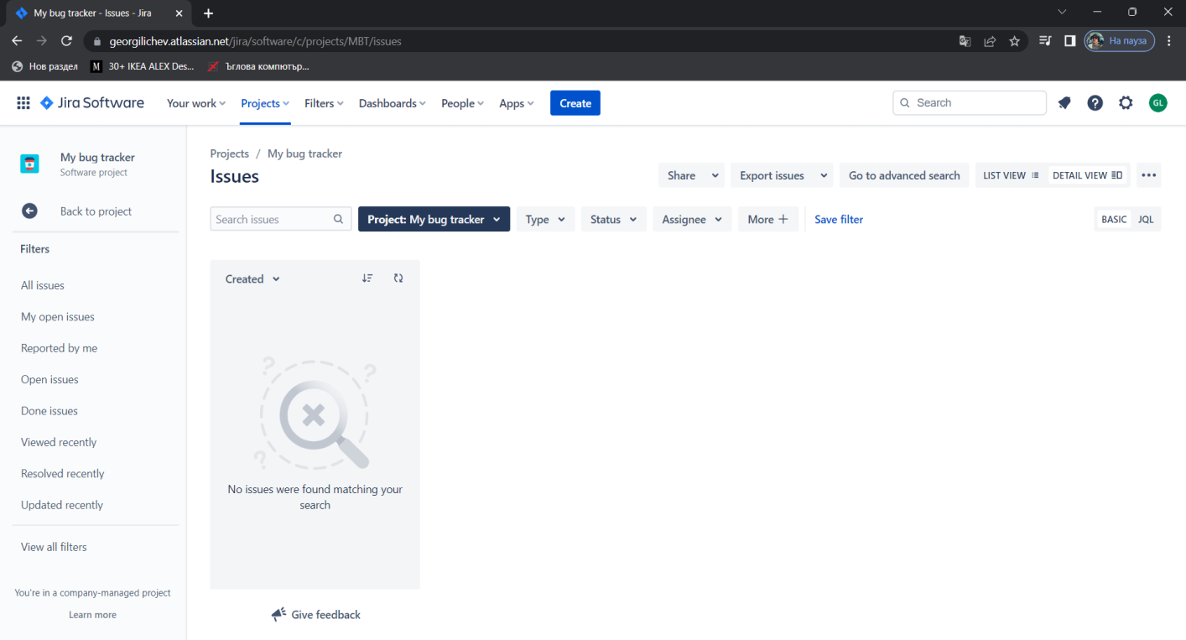

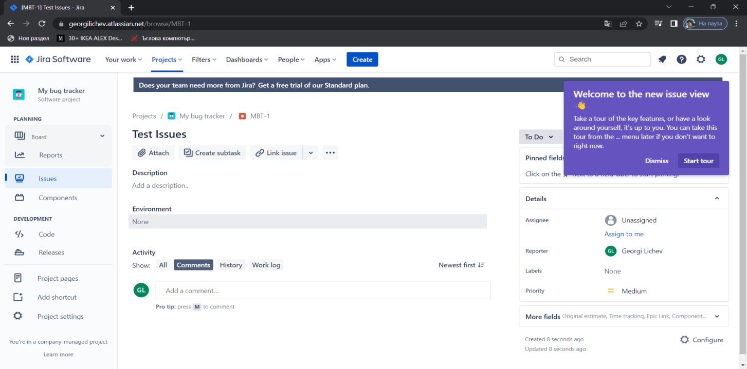

## Bug Reporting: Registration Form

Briefly describe all bugs you have found in the table below. You may add screenshots where it is relevant.

|  |  |
| --- | --- |
| **Bug** | **Description** |
| **Bug #1** | When I fill short username less then 6 chars the form should give a validation error, but it accepts the username. |
| **Bug #2** | [**Clear Form**] button does not work. |
| **Bug #3** | Typo: “Account” typed wrongly.   * **Expected**: Create Your Account * **Actual:** Create Your Acount |
| **Bug #4** | Username should have **max length limit**, e. g. **15 chars**. |
| **Bug #5** | **5-letter password** “Ge1@r” is valid, but should be invalid. |
| **Bug #6** | **Already** used username or email should be **not allowed for registered** |
| **Bug #7** | **Welcome message** mismatch:   * **Expected message**: “Your are now logged in.” * **Actual message**: “Thank you for registering” |
| **Bug #8** | Confirm password label is not correct:   * **Expected**: Confirm Password * **Actual:** Confirm Email |

**Report all bugs** found in your **Jira** project.  
*[Insert a screenshot of your Jira bug tracking project, holding your issues]*

